SEC Form 3
FORM 3 | UNITED STATES SECURITIES AND EXCHANGE COMMISSION  Washington, D.C. 20549  INITIAL STATEMENT OF BENEFICIAL OWNERSHIP OF SECURITIES  Filed pursuant to Section 16(a) of the Securities Exchange Act of 1934  or Section 30(h) of the Investment Company Act of 1940
  OMB APPROVAL
  OMB Number: | 3235-0104
  Estimated average burden
  hours per response: | 0.5
1. Name and Address of Reporting Person*  (Street) | 2. Date of Event Requiring Statement (Month/Day/Year)  08/19/2026 | 3. Issuer Name and Ticker or Trading Symbol  CHARTER COMMUNICATIONS, INC. /MO/ [ CHTR ]  Foreign Trading Symbol
  Taylor Alexander Cox
  (Last) | (First) | (Middle)
  400 WASHINGTON BLVD.
  STAMFORD | CT | 06902
  (City) | (State) | (Zip)
 |  | 4. Relationship of Reporting Person(s) to Issuer  (Check all applicable) | 5. If Amendment, Date of Original Filed (Month/Day/Year)
   | Director |  | 10% Owner
   | Officer (give title below) |  | Other (specify below)
6. Individual or Joint/Group Filing (Check Applicable Line)
Form filed by One Reporting Person
Form filed by More than One Reporting Person

Table I - Non-Derivative Securities Beneficially Owned
1. Title of Security (Instr. 4) | 2. Amount of Securities Beneficially Owned (Instr. 4) | 3. Ownership Form: Direct (D) or Indirect (I) (Instr. 5) | 4. Nature of Indirect Beneficial Ownership (Instr. 5)
Class A Common Stock | 4,000 | D
Table II - Derivative Securities Beneficially Owned
(e.g., puts, calls, warrants, options, convertible securities)
1. Title of Derivative Security (Instr. 4) | 2. Date Exercisable and Expiration Date (Month/Day/Year) |  | 3. Title and Amount of Securities Underlying Derivative Security (Instr. 4) |  | 4. Conversion or Exercise Price of Derivative Security | 5. Ownership Form: Direct (D) or Indirect (I) (Instr. 5) | 6. Nature of Indirect Beneficial Ownership (Instr. 5)
1. Title of Derivative Security (Instr. 4) | Date Exercisable | Expiration Date | Title | Amount or Number of Shares | 4. Conversion or Exercise Price of Derivative Security | 5. Ownership Form: Direct (D) or Indirect (I) (Instr. 5) | 6. Nature of Indirect Beneficial Ownership (Instr. 5)
Charter Communications Holdings Class C Common Units | 08/19/2026(1) | (1) | Issuer Class A Common Stock | 33,586,045(2) | (2) | I | See Footnote(1)(3)(4)
Charter Communications Holdings Convertible Preferred Units | 08/19/2026(1) | (1) | Issuer Class A Common Stock | 12,567,840(5) | 477.41(5) | I | See Footnote(1)(3)(4)
Explanation of Responses:
1. Cox Communications Equity Holdings, Inc. ("CCEH") acquired the Class C Common Units (the "Class C Common Units") and the Convertible Preferred Units (the "Convertible Preferred Units") of Charter Communications Holdings, LLC ("Charter Communications Holdings") disclosed on this Form 3 on August 19, 2026 and such units have no expiration date. CCEH is entitled to voting rights with respect to the Class C Common Units and the Convertible Preferred Units through its ownership of one share of Class C Common Stock, par value $0.001 per share, of the Issuer.
2. Upon exchange by CCEH, the Class C Common Units owned by CCEH will be exchangeable, in certain circumstances, for cash or, at the Issuer's election, Class A Common Stock of the Issuer on a one-for-one basis, subject to certain adjustments.
3. The Reporting Person, by virtue of his affiliations with the Cox Family Voting Trust u/a/d 7/26/13 and Cox Enterprises, Inc., may be deemed to beneficially own the Class C Common Units and the Convertible Preferred Units owned directly by CCEH. CCEH is a wholly owned subsidiary of Cox Enterprises, Inc. and Cox Enterprises, Inc. is an indirect beneficial owner of the reported securities.
4. The Reporting Person disclaims beneficial ownership of the Class C Common Units and the Convertible Preferred Units owned by CCEH and this report shall not be deemed an admission that the Reporting Person is the beneficial owner of such securities for purposes of Section 16 or for any other purpose.
5. Each of the 60,000,000 Convertible Preferred Units, which have an aggregate liquidation preference of $6.0 billion and 6.875% coupon, are convertible into Class C Common Units at an initial conversion price of $477.41 per unit, subject to certain adjustments. Upon exchange by CCEH, the Class C Common Units owned by CCEH will be exchangeable, in certain circumstances, for cash or, at the Issuer's election, Class A Common Stock of the Issuer on a one-for-one basis, subject to certain adjustments.
Remarks:
 | /s/ Alex C. Taylor | 08/19/2026
 | ** Signature of Reporting Person | Date
Reminder: Report on a separate line for each class of securities beneficially owned directly or indirectly.
* If the form is filed by more than one reporting person, see Instruction 5 (b)(v).
** Intentional misstatements or omissions of facts constitute Federal Criminal Violations See 18 U.S.C. 1001 and 15 U.S.C. 78ff(a).
Note: File three copies of this Form, one of which must be manually signed. If space is insufficient, see Instruction 6 for procedure.
Persons who respond to the collection of information contained in this form are not required to respond unless the form displays a currently valid OMB Number.
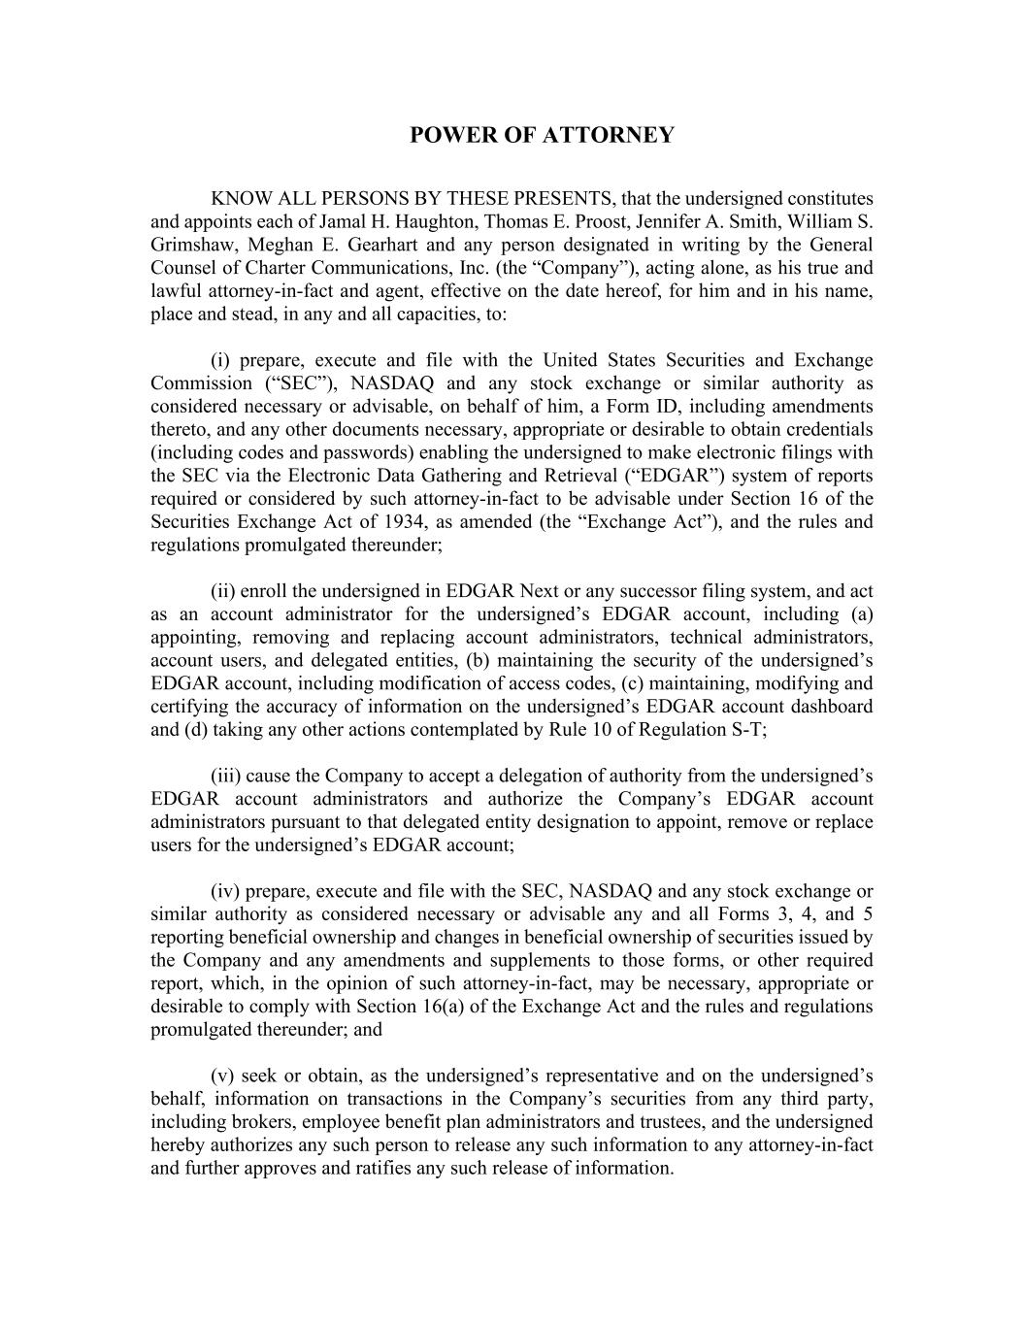
POWER OF ATTORNEY KNOW ALL PERSONS BY THESE PRESENTS, that the undersigned constitutes and appoints each of Jamal H. Haughton, Thomas E. Proost, Jennifer A. Smith, William S. Grimshaw, Meghan E. Gearhart and any person designated in writing by the General Counsel of Charter Communications, Inc. (the “Company”), acting alone, as his true and lawful attorney-in-fact and agent, effective on the date hereof, for him and in his name, place and stead, in any and all capacities, to: (i) prepare, execute and file with the United States Securities and Exchange Commission (“SEC”), NASDAQ and any stock exchange or similar authority as considered necessary or advisable, on behalf of him, a Form ID, including amendments thereto, and any other documents necessary, appropriate or desirable to obtain credentials (including codes and passwords) enabling the undersigned to make electronic filings with the SEC via the Electronic Data Gathering and Retrieval (“EDGAR”) system of reports required or considered by such attorney-in-fact to be advisable under Section 16 of the Securities Exchange Act of 1934, as amended (the “Exchange Act”), and the rules and regulations promulgated thereunder; (ii) enroll the undersigned in EDGAR Next or any successor filing system, and act as an account administrator for the undersigned’s EDGAR account, including (a) appointing, removing and replacing account administrators, technical administrators, account users, and delegated entities, (b) maintaining the security of the undersigned’s EDGAR account, including modification of access codes, (c) maintaining, modifying and certifying the accuracy of information on the undersigned’s EDGAR account dashboard and (d) taking any other actions contemplated by Rule 10 of Regulation S-T; (iii) cause the Company to accept a delegation of authority from the undersigned’s EDGAR account administrators and authorize the Company’s EDGAR account administrators pursuant to that delegated entity designation to appoint, remove or replace users for the undersigned’s EDGAR account; (iv) prepare, execute and file with the SEC, NASDAQ and any stock exchange or similar authority as considered necessary or advisable any and all Forms 3, 4, and 5 reporting beneficial ownership and changes in beneficial ownership of securities issued by the Company and any amendments and supplements to those forms, or other required report, which, in the opinion of such attorney-in-fact, may be necessary, appropriate or desirable to comply with Section 16(a) of the Exchange Act and the rules and regulations promulgated thereunder; and (v) seek or obtain, as the undersigned’s representative and on the undersigned’s behalf, information on transactions in the Company’s securities from any third party, including brokers, employee benefit plan administrators and trustees, and the undersigned hereby authorizes any such person to release any such information to any attorney-in-fact and further approves and ratifies any such release of information.

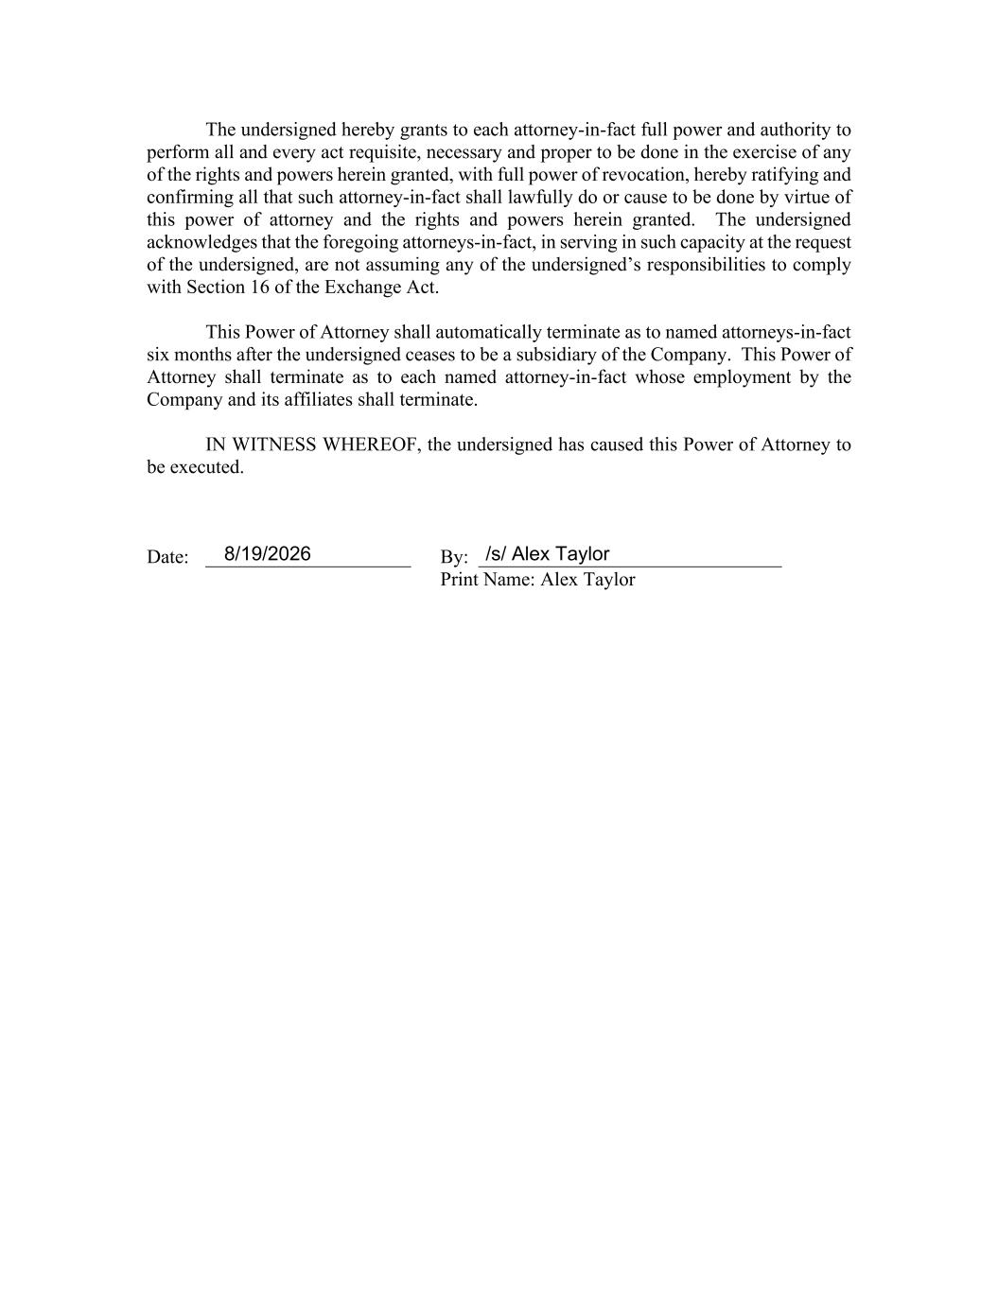
The undersigned hereby grants to each attorney-in-fact full power and authority to perform all and every act requisite, necessary and proper to be done in the exercise of any of the rights and powers herein granted, with full power of revocation, hereby ratifying and confirming all that such attorney-in-fact shall lawfully do or cause to be done by virtue of this power of attorney and the rights and powers herein granted. The undersigned acknowledges that the foregoing attorneys-in-fact, in serving in such capacity at the request of the undersigned, are not assuming any of the undersigned’s responsibilities to comply with Section 16 of the Exchange Act. This Power of Attorney shall automatically terminate as to named attorneys-in-fact six months after the undersigned ceases to be a subsidiary of the Company. This Power of Attorney shall terminate as to each named attorney-in-fact whose employment by the Company and its affiliates shall terminate. IN WITNESS WHEREOF, the undersigned has caused this Power of Attorney to be executed. Date: _____________________ By: _______________________________ Print Name: Alex Taylor /s/ Alex Taylor8/19/2026

